41. Задание

Imagine that you are preparing a project with your friend. You have found some interesting material for the presentation and you want to read this text to your friend. You have 1.5 minutes to read the text silently, then be ready to read it out aloud. You will not have more than 1.5 minutes to read it.

Half the human beings who have ever died, perhaps as many as 45 billion people, have been killed by female mosquitoes. Mosquitoes carry more than a hundred potentially fatal diseases including malaria, yellow fever and elephantiasis. Even today, they kill one person every twelve seconds. Amazingly, nobody had any idea that mosquitoes were dangerous until the end of the nineteenth century. In 1877, the British doctor Sir Patrick Manson proved that yellow fever was caused by mosquito bites.
Seventeen years later it occurred to him that malaria might also be caused by mosquitoes. He encouraged his pupil Ronald Ross to test the hypothesis. Ross was the first person to show how female mosquitoes transmit the parasite. Manson went one better. To show that the theory worked for humans, he infected his own son – using mosquitoes carried in the diplomatic bag from Rome.

42. Задание
Study the advertisement.

You are considering visiting the real estate agency and you'd like to get more information. In 1.5 minutes you are to ask five direct questions to find out the following:
1) location of the agency
2) services they provide
3) if they work at weekends
4) competitive advantages
5) if they provide any guarantees
You have 20 seconds to ask each question.

43. Задание
These are photos from your photo album. Choose one photo to describe to your friend.

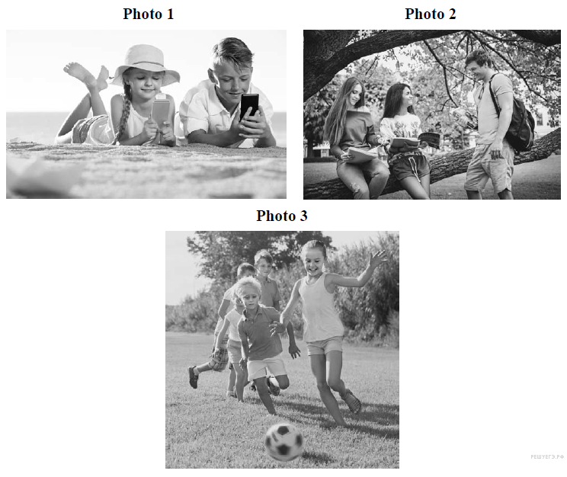

You will have to start speaking in 1.5 minutes and will speak for not more than 2 minutes (12–15 sentences). In your talk remember to speak about:
• where and when the photo was taken
• what/who is in the photo
• what is happening
• why you keep the photo in your album
• why you decided to show the picture to your friend
You have to talk continuously, starting with: "I’ve chosen photo number… "

44. Задание
Study the two photographs. In 1.5 minutes be ready to compare and contrast the photographs:

• give a brief description of the photos (action, location)
• say what the pictures have in common
• say in what way the pictures are different
• say what kind of work presentedin the photos you prefer
• explain why

You will speak for not more than 2 minutes (12–15 sentences). You have to talk continuously.

