London sights
Mark the pictures with numbers, the text must be marked with letters.
Match the sights with their descriptions.
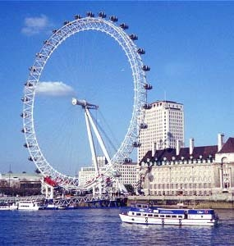 | 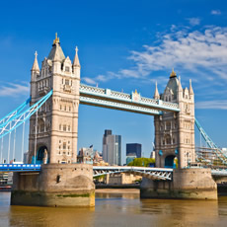 | 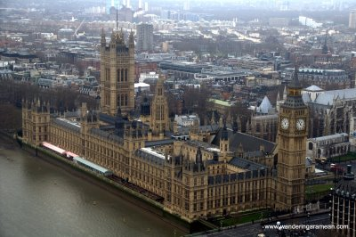
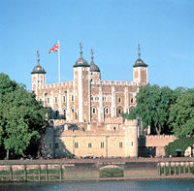 | 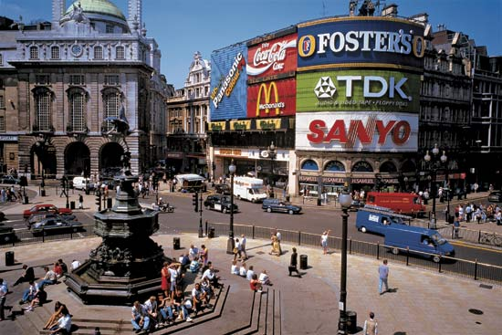 | 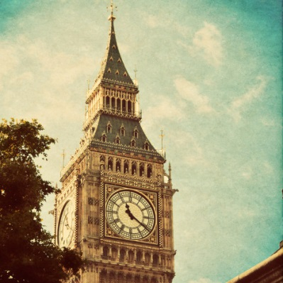
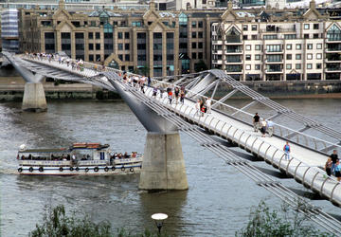 | 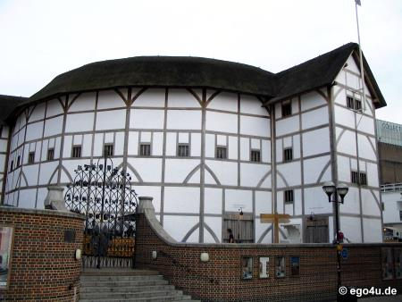 | 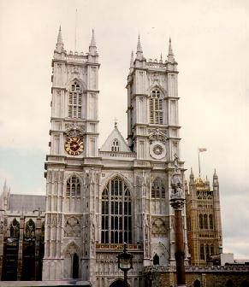
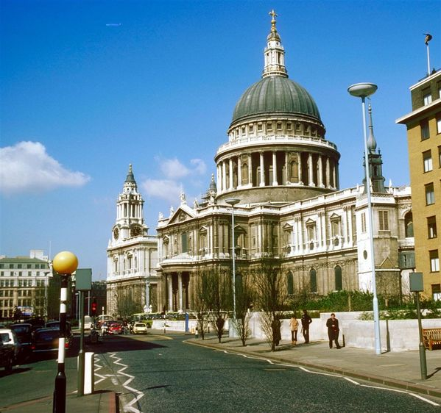 | 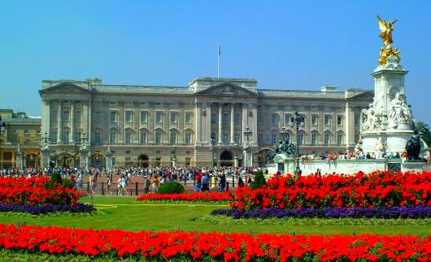 | 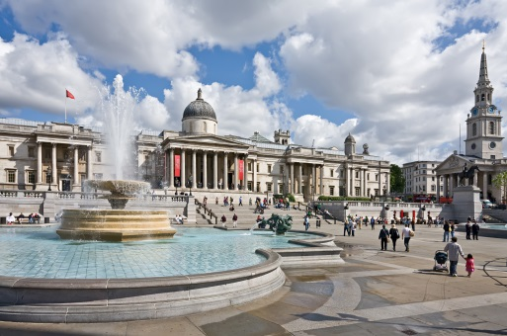
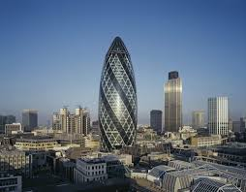 | London Eye | Tower Bridge
The Houses of Parliament | The Tower of London | Piccadilly Circus
Big Ben | Millenium Bridge | Globe Theatre
Westminster Abbey | St. Paul´s  Cathedral | Buckingham  Palace
Trafalgar Square | London Gherkin/ 30 St Mary Axe | 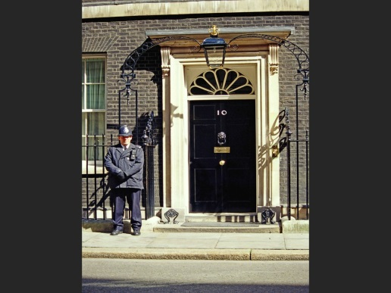
10 Downing Street

This structure lies in the historic area of London.  This skyscraper has 41storeys and it was built in 2004. | This is one of the most popular tourist attractions. It is the highest observation wheel in the world and it was built to celebrate the millennium.
This old building is a castle that stands near Tower Bridge. In the past it was a royal palace – several kings lived there. It was also a prison and many famous people were in prison there (Elizabeth I, Anne Boleyn, Catherine Howard, Sir Walter Raleigh).  It was a royal zoo and observatory too. | This bridge was built in the 19th century. It is the only bridge that can open in the middle so that large ships can pass through.
This is a complex of buildings. It is the place where the parliament meets and where the Prime Minister and the government work. | This beautiful white building is the Queen´s home. The first queen who lived there was Queen Victoria in the 19th century. The Royal Flag is flying there when the Queen is at home.
This round white building was a theatre that was built in 1599. It was famous because many Shakespeare´s plays were shown there. In 1644 the theatre was destroyed by fire and a new theatre was built there in 1997. | This bridge is a suspension bridge for pedestrians. You can only walk there. The bridge was open in 2000 to celebrate a new millennium.
It is the most famous landmark in London. The name refers (se vztahuje) to the clock that weighs about 13 tons and is inside the big tower. | It is one of the oldest buildings in London. Queens and Kings are crowned there.
It is a square and it is named after a great British victory. The Battle of Trafalgar was won by Admiral Nelson. In the middle of the square there is the Nelson´s column with the statue of Admiral Nelson. Every Christmas there is the Christmas tree that stands in the middle of the square. | This street is famous because it is a place where the British Prime Minister lives and works. The Prime Minister is David Cameron.
It is the main traffic intersection (křižovatka) and is most famous for its neon signs. In the centre there is a fountain with a statue of God of Love – Eros. | This is a large white cathedral. Inside the dome (kupole) there is the Whispering Gallery. When you whisper against the wall, the person on the other side can hear your words. In 1981 Prince Charles and Princes Diana married there.

